Notes

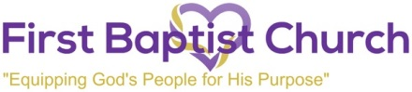

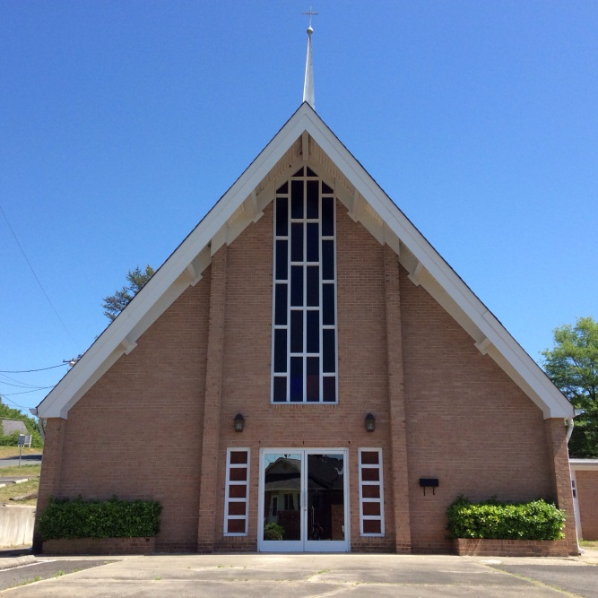

August 1st, 2021

HOMECOMING SERVICE
Rev. Dr. Anthony E. Neal, Pastor
201 Wayne Street
Post Office 1636
Badin, NC 28009
www.fbcbadin.org
www.facebook.com/firstbaptistchurchbadin

Worship Schedule
9:45 a.m. Sunday School
11:00 a.m. Sunday Morning Worship
Holy Communion Every First Sunday
Prayer Meeting Call-In Number:
712-775-7031 Meeting I.D. 240-412-063

First Baptist Church
Rev. Dr. Anthony E. Neal, Pastor
201 Wayne Street
Post Office Box 1636
Badin, North Carolina 28009

August 1st 2021
Homecoming Service

11:00 Praise and Worship

Call to Worship
(Congregation please stand)

Invocation

Scripture Reading - John 6:24-35

Selection – Praise Him, Praise Him

Welcome & Recognition of Visitors, Announcements

Tithes and Offerings

Selection – Amazing Grace

Morning message - Pastor Anthony Neal

Invitation/Call to Christian Discipleship/Prayer

Selection – Are you washed in the Blood

Holy Communion

Benediction

Announcements

WELCOME BACK FBC FAMILY – HAPPY HOMECOMING

We ask that everyone please wear a mask during the entirety of the service and keep your mask on while going to other areas of the church.

Please sanitize your hands frequently and social distance as much as possible so that we keep everyone safe.

If you have not received the COVID-19 vaccination, it is encouraged that you do so, so that we can keep our families and communities safe.

Healing and Recovering Members
Sis. Sybil Chandler
Sis Sadie Knight
Sis Eula Lewis
Sis Agatha Lovelace
Sister Geraldine Little
Brother Jamie Devins

Let us continue to be in prayer for the bereaved families.

